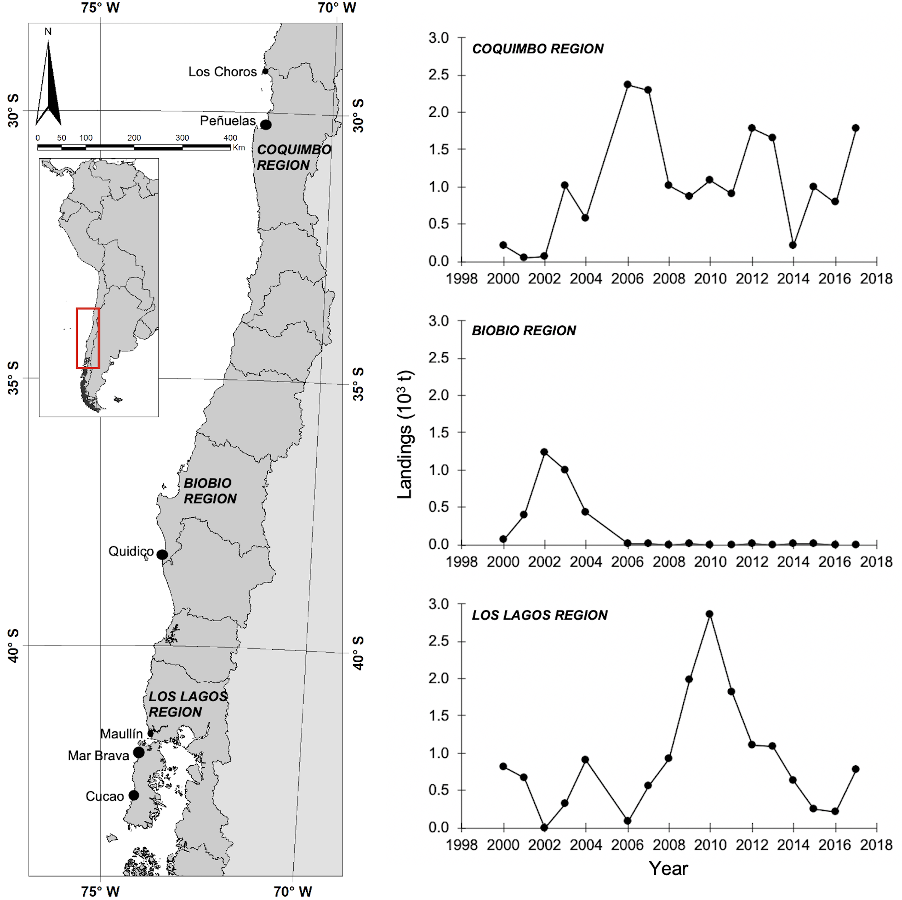

Figure 1. Principal landing points of surf clam *M. donacium* along the Chilean coast (left), and performance of regional landings from 2000 (right). Source: National Fisheries and Aquaculture Service.

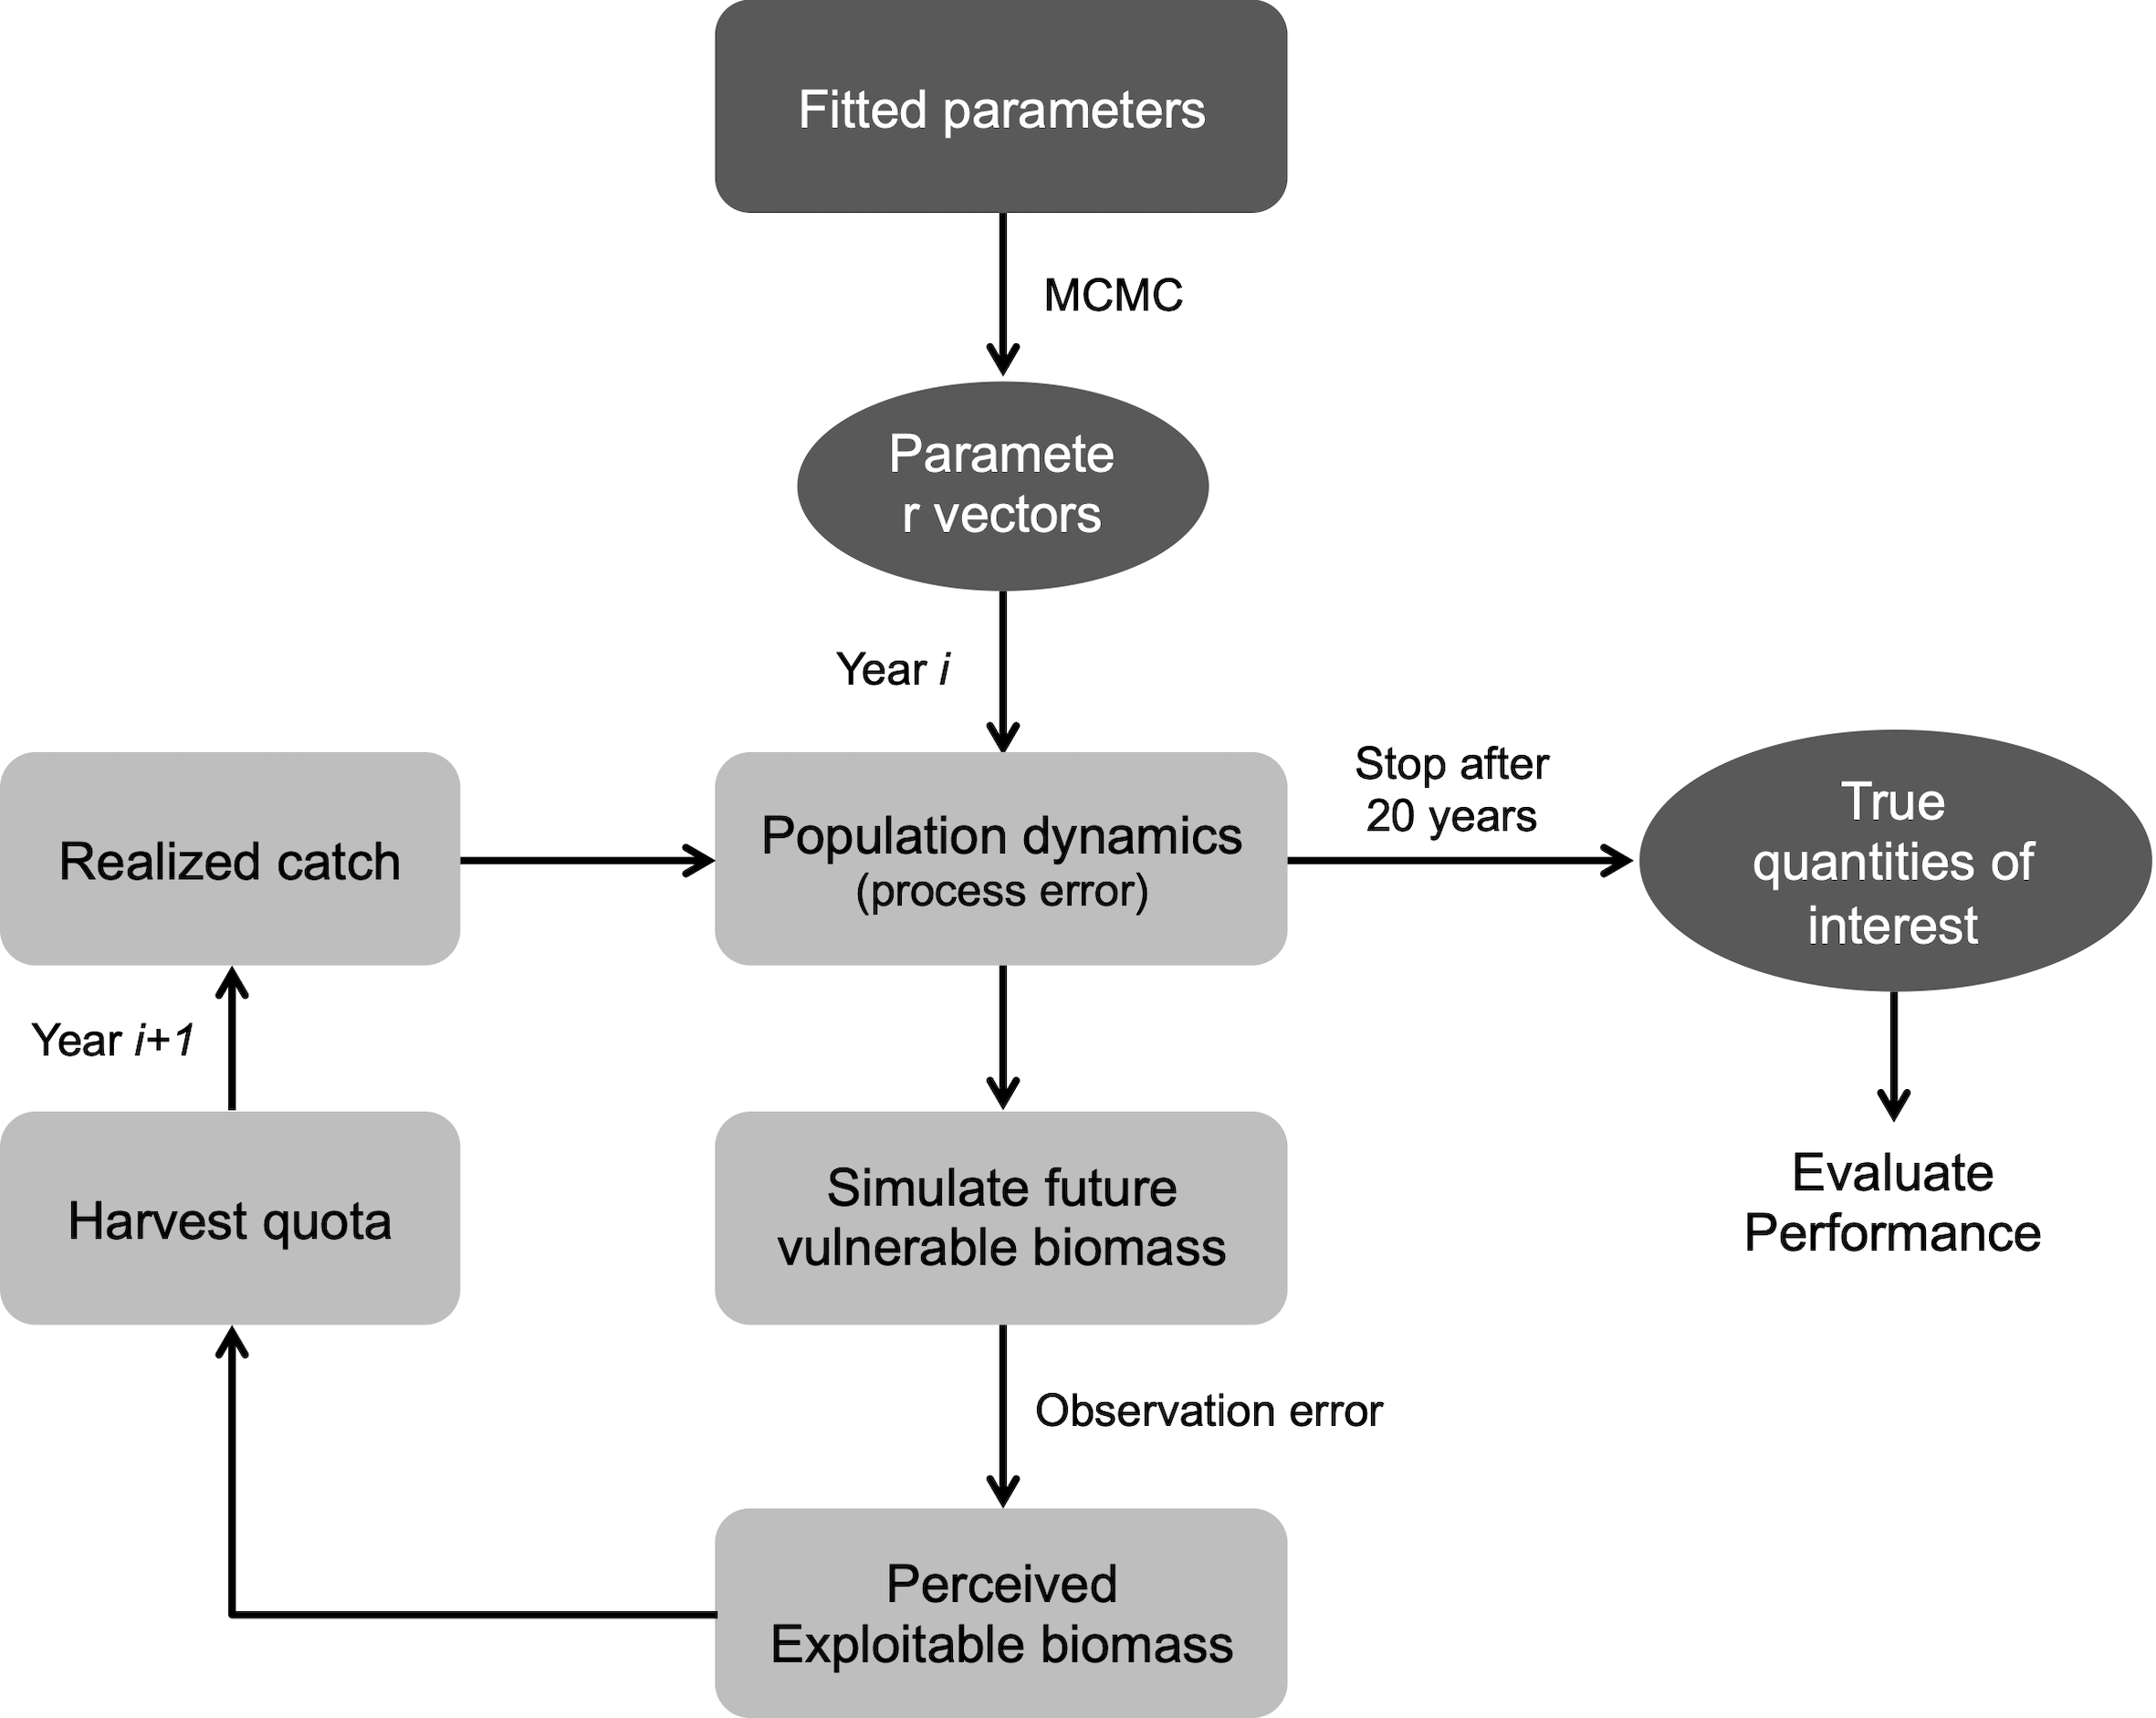

Figure 2. General simulation procedure implemented for the surf clam *M. donacium* in the AMEBR Cucao.

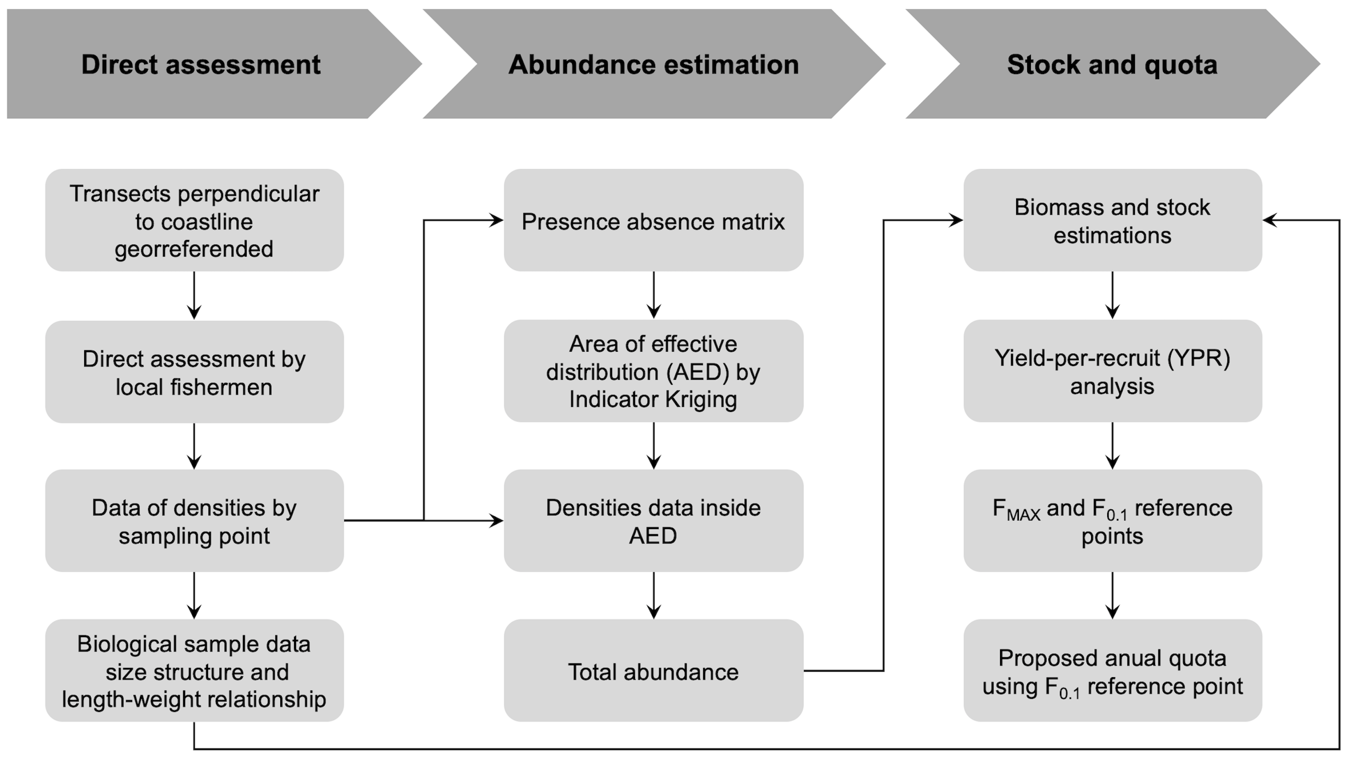

Figure 3. Current management procedure for the surf clam *M. donacium* in the AMEBR Cucao.

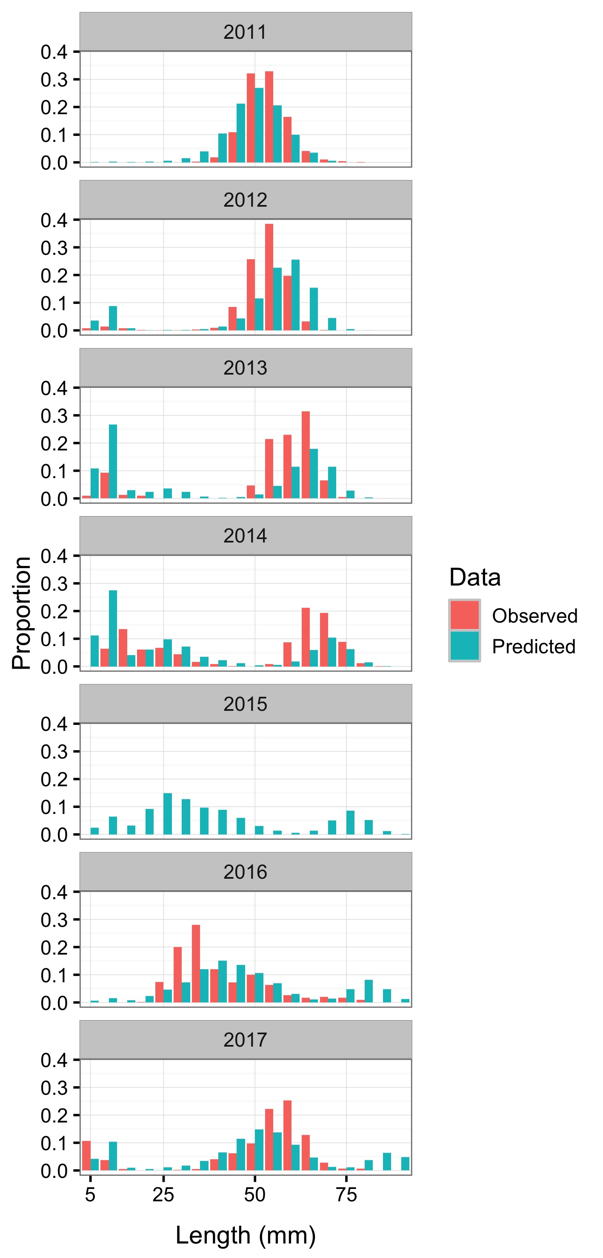

Figure 4. Observed and predicted length composition of surf clam *Mesodesma donacium* at Cucao in 2011-2017. The predicted length composition comes from the conditioned operating model.

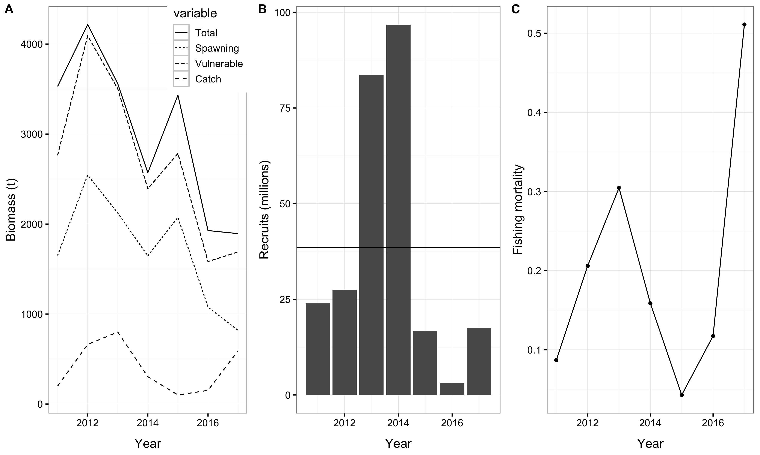

Figure 5. Population biomasses and catch (A), annual recruitment (B), and fishing mortality rate (C) of surf clam *Mesodesma donacium* at Cucao during 2011-2017 obtained from the conditioned operating model.

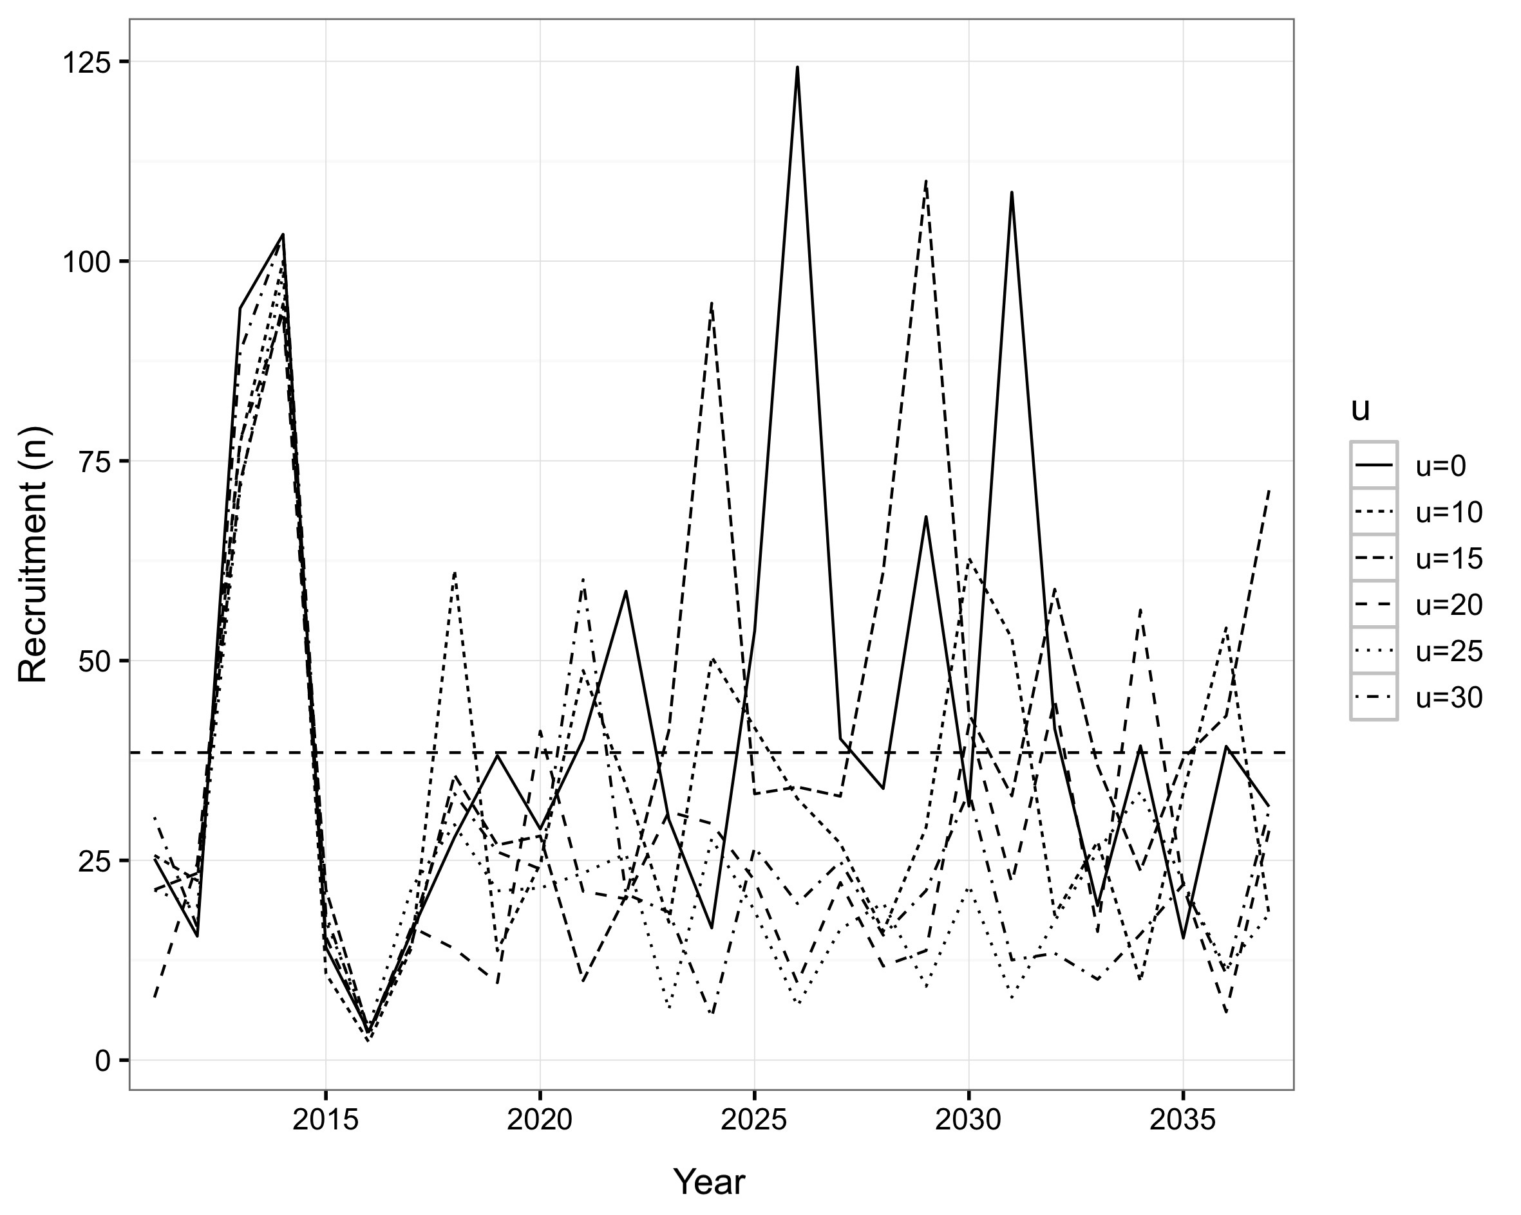

Figure 6. Single realizations of simulated future recruitment for surf clam *Mesodesma donacium* using 8 different harvest rates.

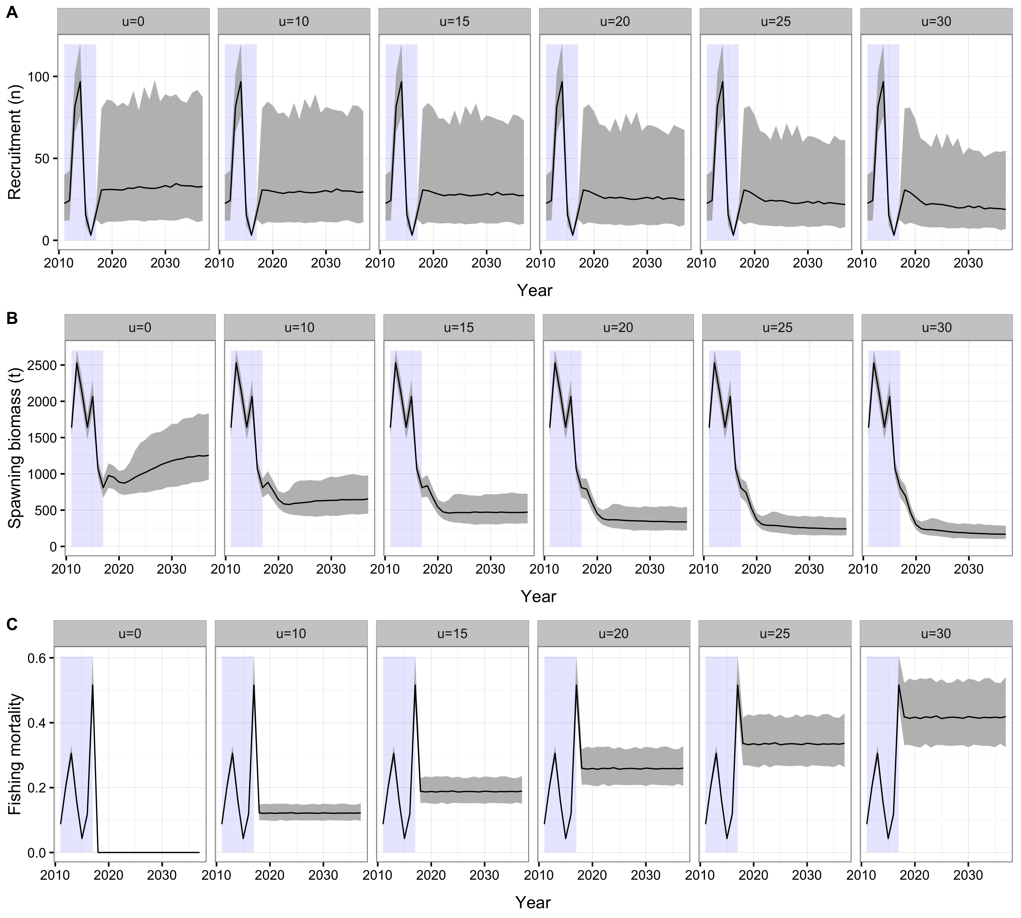

Figure 7. Summary of 500 simulations of projected recruitment (A), and responses in the spawning biomass (B) and fishing mortality (C) of the surf clam *Mesodesma donacium* at Cucao beach using 6 different (and constant) exploitation rates. Light purple shading indicates observed data from 2011 to 2017. Gray shading corresponds to 90% confidence limits for projected variables.

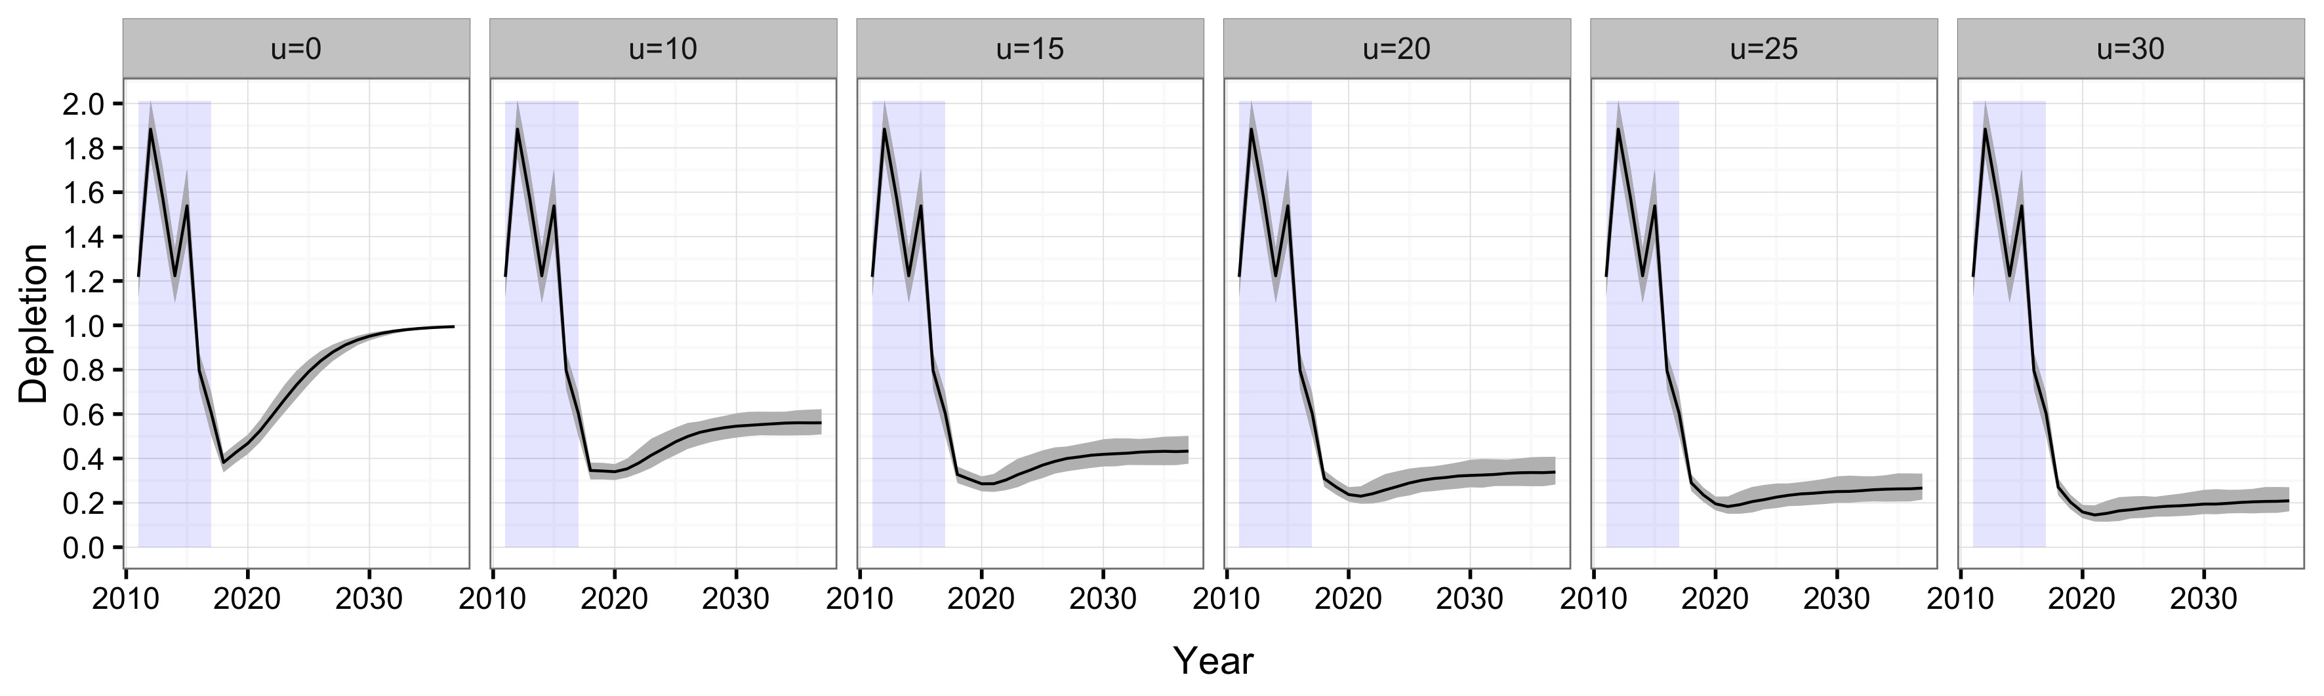

Figure 8. Expected depletion of the spawning biomass of surf clam *Mesodesma donacium* at Cucao beach according to six different exploitation rates. Light purple shading indicates observed data from 2010 to 2017. Gray shading corresponds to 95% confidence intervals for expected depletion.

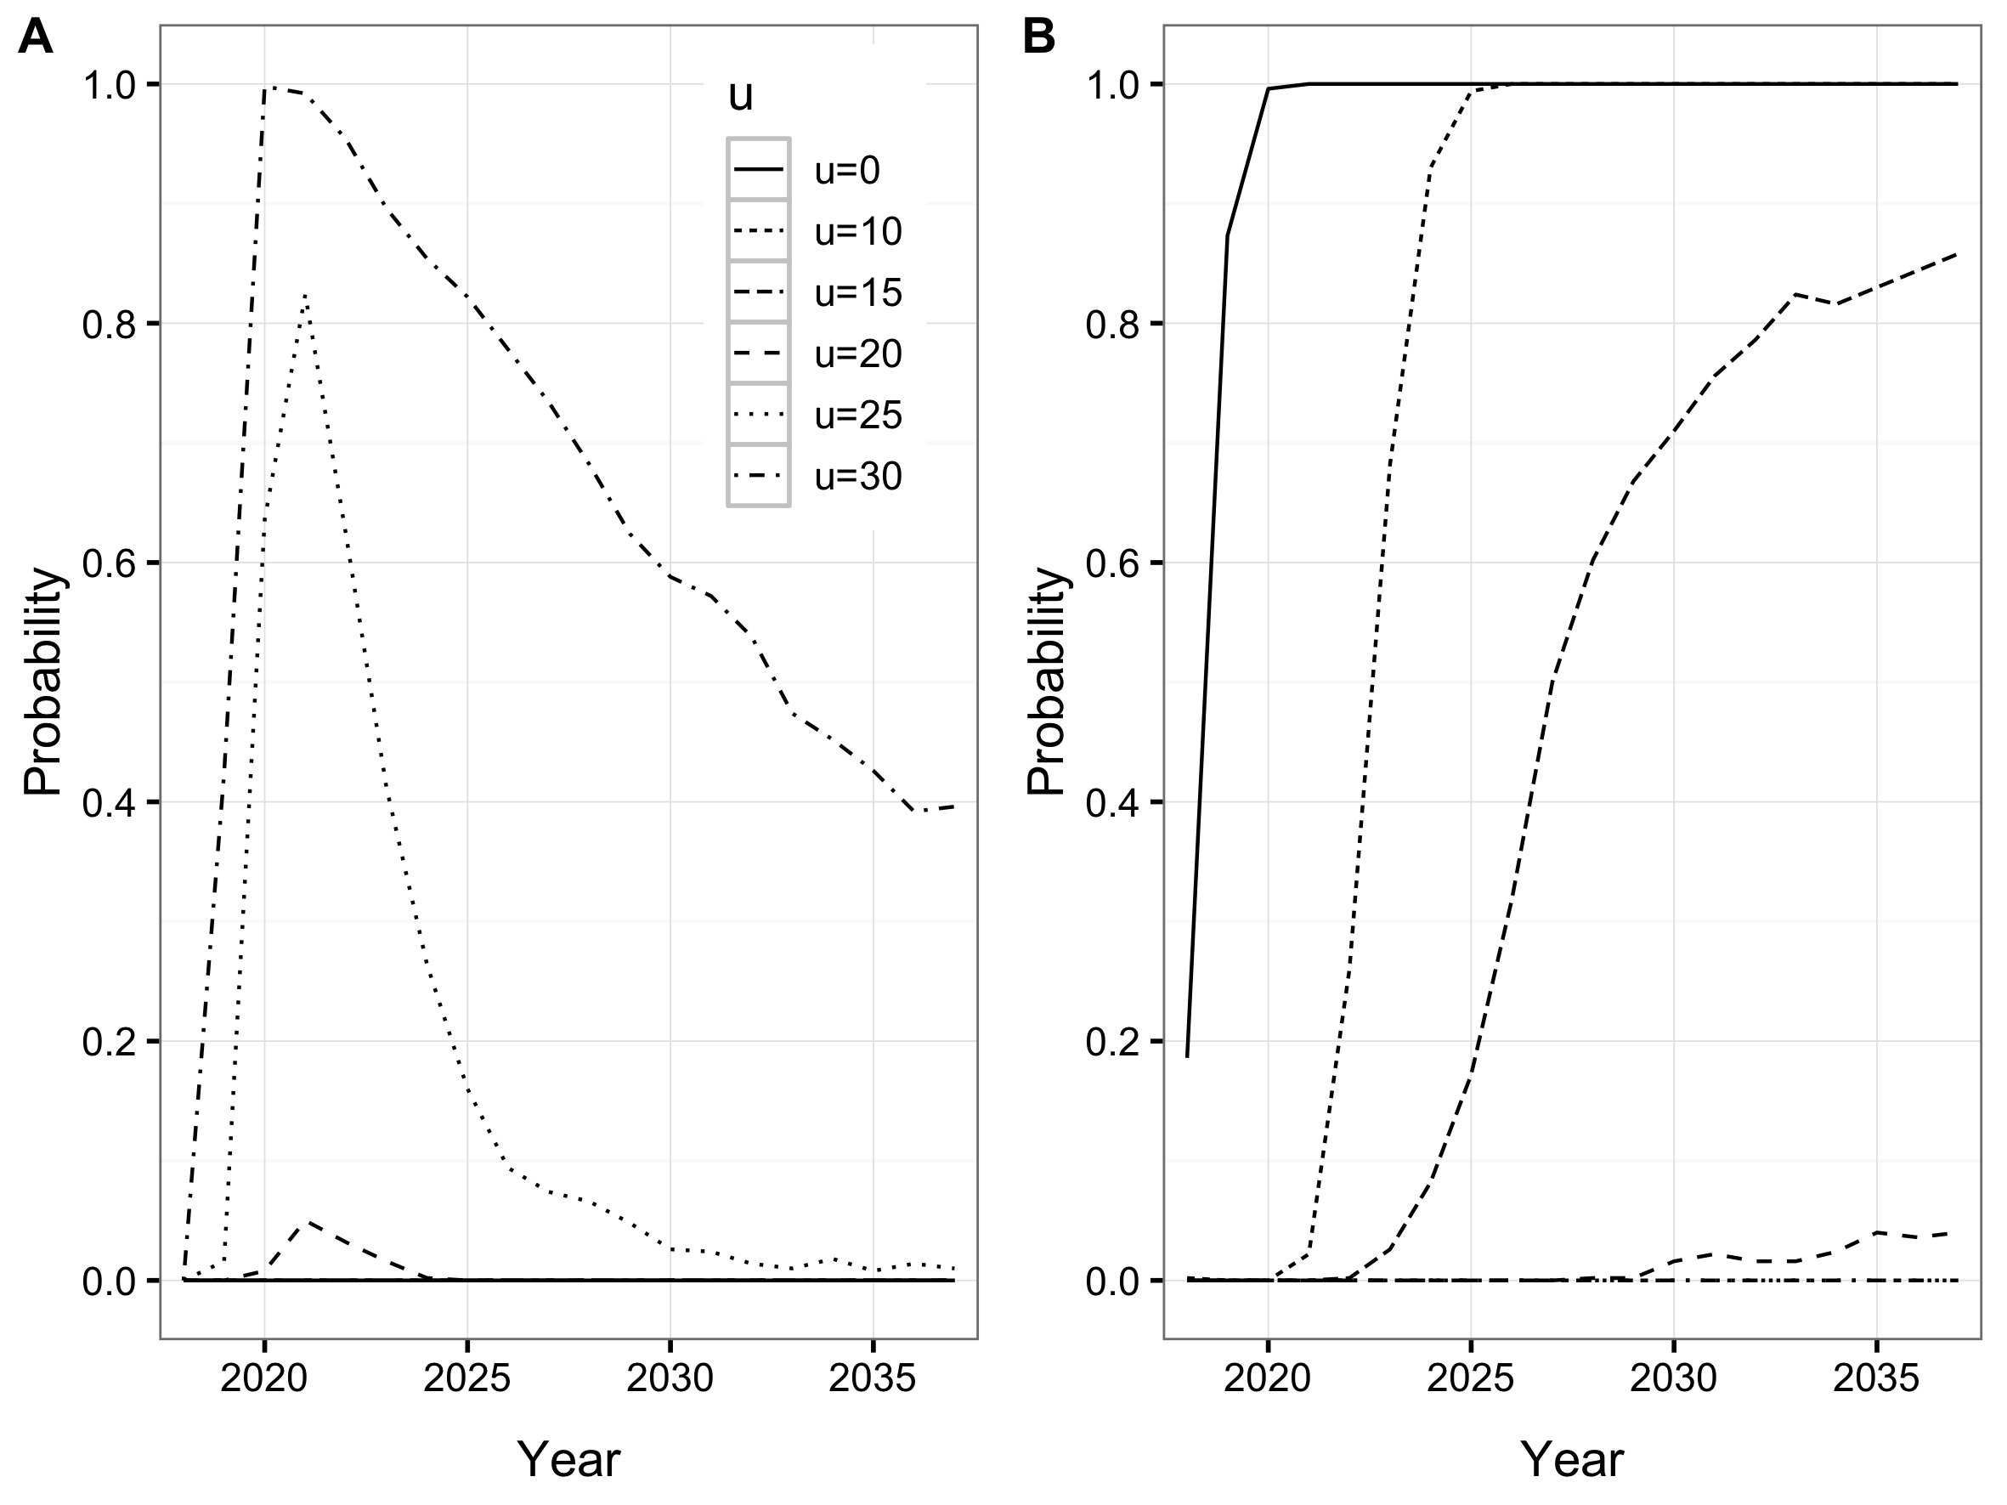

Figure 9. Probability of collapse (A) and the probability of achieving the target biomass (B) of 40% surf clam spawning biomass at Cucao beach under different exploitation rates (colored lines).